Vatican City
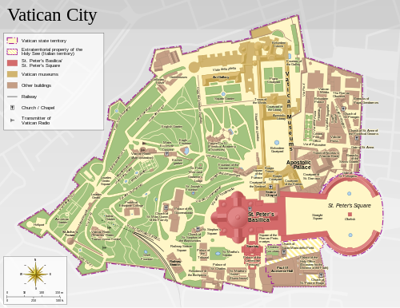
Chronology
c.60 Church of Rome founded by the Apostle Peter.
14 Apr 754 Donation of the Frankish ruler Pepin creates
a temporal Papal State for the Popes of the
Roman Catholic Church (also called the Papal
State or the States of the Church)
(see Papal State under Italian states).
9 Mar 1309 - 17 Jan 1377 Popes rule from Avignon in France, era is
referred to as the "Babylonian Captivity
of the Church" by some historians.
15 Feb 1798 - 23 Nov 1798 In rebellion: Roman Republic.
10 Jun 1809 - 24 Mar 1814 Papal State annexed to France
26 Feb 1831 - 26 Mar 1831 In rebellion: United Italian Provinces.
9 Feb 1849 - 4 Jul 1849 In rebellion: Roman Republic.
9 Oct 1870 Papal State annexed by Italy.
9 Oct 1870 - 7 Jun 1929 Popes rule in seclusion in the Vatican Palace
as "Prisoners in the Vatican."
7 Jun 1929 State of Vatican City established (Stato della
Città del Vaticano/Status Civitatis Vaticanae); independence from Italy by the Lateran Treaty signed on 11 Feb 1929.
22 Dec 1947 Italian Constitution enshrines the Lateran Treaty.
6 Apr 1964 Becomes a permanent observer at the United Nations.
3 Jun 1985 Revised Lateran Pacts effected, signed 18 Feb 1984.
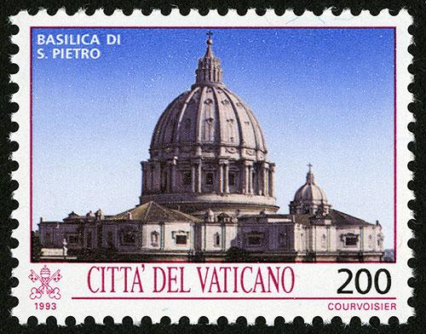
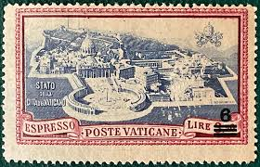

Sovereigns
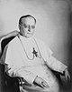 | 7 Jun 1929 - 10 Feb 1939 Pius XI (b. 1857 - d. 1939)
10 Feb 1939 - 2 Mar 1939 Gennaro Cardinal Granito
Pignatelli di Belmonte
(b. 1851 - d. 1948) (dean of the College of Cardinals) + Eugenio Cardinal Pacelli (b. 1876 - d. 1958)
(chamberlain)
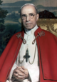 | 2 Mar 1939 - 9 Oct 1958 Pius XII (= Pacelli) (s.a.)
9 Oct 1958 - 28 Oct 1958 Eugène-Gabriel-Gervais-Laurent
Cardinal Tisserant (1st time) (b. 1884 - d. 1972)
(dean of the College of Cardinals)
+ Benedetto Cardinal Aloisi
Masella (1st time) (chamberlain) (b. 1879 - d. 1970)
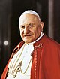 | 28 Oct 1958 - 3 Jun 1963 Ioannes XXIII  (b. 1881 - d. 1963)
3 Jun 1963 - 21 Jun 1963 Eugène-Gabriel-Gervais-Laurent
Cardinal Tisserant (2nd time) (s.a.)
(dean of the College of Cardinals)
+ Benedetto Cardinal Aloisi
Masella (2nd time) (chamberlain) (s.a.)
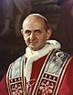 | 21 Jun 1963 - 6 Aug 1978 Paulus VI  (b. 1897 - d. 1978)
6 Aug 1978 - 26 Aug 1978 Carlo Cardinal Confalonieri
(1st time) (b. 1893 - d. 1986)
(dean of the College of Cardinals)
+ Jean Cardinal Villot (1st time) (b. 1905 - d. 1979)
(chamberlain)
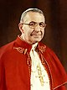 | 26 Aug 1978 - 28 Sep 1978 Ioannes Paulus I  (b. 1912 - d. 1978)
28 Sep 1978 - 16 Oct 1978 Carlo Cardinal Confalonieri
(2nd time) (s.a.)
(dean of the College of Cardinals)
+ Jean Cardinal Villot (2nd time) (s.a.)
(chamberlain)
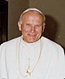 | 16 Oct 1978 - 2 Apr 2005 Ioannes Paulus II  (b. 1920 - d. 2005)
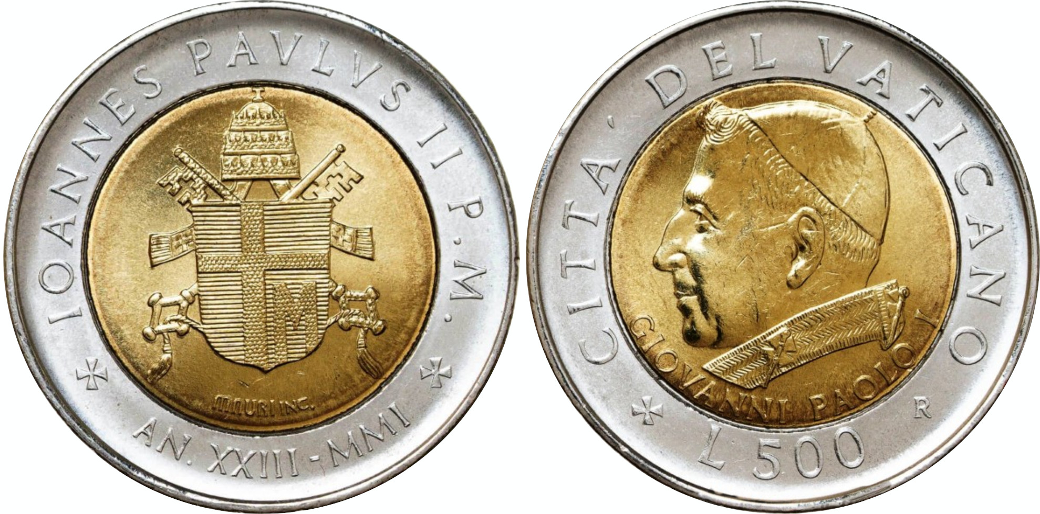
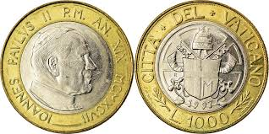
2 Apr 2005 - 19 Apr 2005 Joseph Cardinal Ratzinger (b. 1927)
(dean of the College of Cardinals)
+ Eduardo Cardinal Martínez Somalo (b. 1927)
(chamberlain)
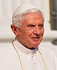 | 19 Apr 2005 - 28 Feb 2013 Benedictus XVI (= Ratzinger) (s.a.)
28 Feb 2013 - 13 Mar 2013 Angelo Cardinal Sodano (b. 1927)
(dean of the College of Cardinals)
+ Tarcisio Cardinal Bertone (b. 1934)
(chamberlain)
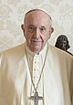 | 13 Mar 2013 - Franciscus (b. 1936)

Secretaries of state
13 Oct 1914 - 9 Feb 1930 Pietro Cardinal Gasparri (b. 1852 - d. 1934)
9 Feb 1930 - 10 Feb 1939 Eugenio Cardinal Pacelli (s.a.)
11 Mar 1939 - 22 Aug 1944 Luigi Cardinal Maglione (b. 1877 - d. 1944)
29 Nov 1952 - 30 Jul 1961 Domenico Tardini (from 15 Dec
1958, Domenico Cardinal Tardini) (b. 1888 - d. 1961)
(acting to 14 Dec 1958)
14 Aug 1961 - 2 May 1969 Amleto Giovanni Cardinal Cicognani (b. 1883 - d. 1973)
2 May 1969 - 9 Mar 1979 Jean Cardinal Villot (s.a.)
30 Apr 1979 - 1 Dec 1990 Agostino Casaroli (from 30 Jun
1979, Agostino Cardinal Casaroli) (b. 1914 - d. 1998)
(acting to 1 Jul 1979)
1 Dec 1990 - 15 Sep 2006 Angelo Sodano (from 28 Jun 1991,
Angelo Cardinal Sodano) (s.a.)
(acting to 29 Jun 1991)
15 Sep 2006 - 15 Oct 2013 Tarcisio Cardinal Bertone (s.a.)
15 Oct 2013 - Pietro Parolin (from 22 Feb 2014,
Pietro Cardinal Parolin) (b. 1955)

INCLUDEPICTURE "http://t0.gstatic.com/images?q=tbn:ANd9GcTDT1jpfS6n_Y4NmsXFnf0dV2uAk854tEHeOSaIXPxUCt7qxHu5xaSaZA" \* MERGEFORMATINET INCLUDEPICTURE "http://t0.gstatic.com/images?q=tbn:ANd9GcTDT1jpfS6n_Y4NmsXFnf0dV2uAk854tEHeOSaIXPxUCt7qxHu5xaSaZA" \* MERGEFORMATINET INCLUDEPICTURE "http://t0.gstatic.com/images?q=tbn:ANd9GcTDT1jpfS6n_Y4NmsXFnf0dV2uAk854tEHeOSaIXPxUCt7qxHu5xaSaZA" \* MERGEFORMATINET INCLUDEPICTURE "http://t0.gstatic.com/images?q=tbn:ANd9GcTDT1jpfS6n_Y4NmsXFnf0dV2uAk854tEHeOSaIXPxUCt7qxHu5xaSaZA" \* MERGEFORMATINET INCLUDEPICTURE "http://t0.gstatic.com/images?q=tbn:ANd9GcTDT1jpfS6n_Y4NmsXFnf0dV2uAk854tEHeOSaIXPxUCt7qxHu5xaSaZA" \* MERGEFORMATINET INCLUDEPICTURE "http://t0.gstatic.com/images?q=tbn:ANd9GcTDT1jpfS6n_Y4NmsXFnf0dV2uAk854tEHeOSaIXPxUCt7qxHu5xaSaZA" \* MERGEFORMATINET INCLUDEPICTURE "http://t0.gstatic.com/images?q=tbn:ANd9GcTDT1jpfS6n_Y4NmsXFnf0dV2uAk854tEHeOSaIXPxUCt7qxHu5xaSaZA" \* MERGEFORMATINET INCLUDEPICTURE "http://t0.gstatic.com/images?q=tbn:ANd9GcTDT1jpfS6n_Y4NmsXFnf0dV2uAk854tEHeOSaIXPxUCt7qxHu5xaSaZA" \* MERGEFORMATINET INCLUDEPICTURE "http://t0.gstatic.com/images?q=tbn:ANd9GcTDT1jpfS6n_Y4NmsXFnf0dV2uAk854tEHeOSaIXPxUCt7qxHu5xaSaZA" \* MERGEFORMATINET INCLUDEPICTURE "http://t0.gstatic.com/images?q=tbn:ANd9GcTDT1jpfS6n_Y4NmsXFnf0dV2uAk854tEHeOSaIXPxUCt7qxHu5xaSaZA" \* MERGEFORMATINET INCLUDEPICTURE "http://t0.gstatic.com/images?q=tbn:ANd9GcTDT1jpfS6n_Y4NmsXFnf0dV2uAk854tEHeOSaIXPxUCt7qxHu5xaSaZA" \* MERGEFORMATINET INCLUDEPICTURE "http://t0.gstatic.com/images?q=tbn:ANd9GcTDT1jpfS6n_Y4NmsXFnf0dV2uAk854tEHeOSaIXPxUCt7qxHu5xaSaZA" \* MERGEFORMATINET INCLUDEPICTURE "http://t0.gstatic.com/images?q=tbn:ANd9GcTDT1jpfS6n_Y4NmsXFnf0dV2uAk854tEHeOSaIXPxUCt7qxHu5xaSaZA" \* MERGEFORMATINET INCLUDEPICTURE "http://t0.gstatic.com/images?q=tbn:ANd9GcTDT1jpfS6n_Y4NmsXFnf0dV2uAk854tEHeOSaIXPxUCt7qxHu5xaSaZA" \* MERGEFORMATINET INCLUDEPICTURE "http://t0.gstatic.com/images?q=tbn:ANd9GcTDT1jpfS6n_Y4NmsXFnf0dV2uAk854tEHeOSaIXPxUCt7qxHu5xaSaZA" \* MERGEFORMATINET INCLUDEPICTURE "http://t0.gstatic.com/images?q=tbn:ANd9GcTDT1jpfS6n_Y4NmsXFnf0dV2uAk854tEHeOSaIXPxUCt7qxHu5xaSaZA" \* MERGEFORMATINET INCLUDEPICTURE "http://t0.gstatic.com/images?q=tbn:ANd9GcTDT1jpfS6n_Y4NmsXFnf0dV2uAk854tEHeOSaIXPxUCt7qxHu5xaSaZA" \* MERGEFORMATINET INCLUDEPICTURE "http://t0.gstatic.com/images?q=tbn:ANd9GcTDT1jpfS6n_Y4NmsXFnf0dV2uAk854tEHeOSaIXPxUCt7qxHu5xaSaZA" \* MERGEFORMATINET INCLUDEPICTURE "http://t0.gstatic.com/images?q=tbn:ANd9GcTDT1jpfS6n_Y4NmsXFnf0dV2uAk854tEHeOSaIXPxUCt7qxHu5xaSaZA" \* MERGEFORMATINET INCLUDEPICTURE "http://t0.gstatic.com/images?q=tbn:ANd9GcTDT1jpfS6n_Y4NmsXFnf0dV2uAk854tEHeOSaIXPxUCt7qxHu5xaSaZA" \* MERGEFORMATINET INCLUDEPICTURE "http://t0.gstatic.com/images?q=tbn:ANd9GcTDT1jpfS6n_Y4NmsXFnf0dV2uAk854tEHeOSaIXPxUCt7qxHu5xaSaZA" \* MERGEFORMATINET INCLUDEPICTURE "http://t0.gstatic.com/images?q=tbn:ANd9GcTDT1jpfS6n_Y4NmsXFnf0dV2uAk854tEHeOSaIXPxUCt7qxHu5xaSaZA" \* MERGEFORMATINET INCLUDEPICTURE "http://t0.gstatic.com/images?q=tbn:ANd9GcTDT1jpfS6n_Y4NmsXFnf0dV2uAk854tEHeOSaIXPxUCt7qxHu5xaSaZA" \* MERGEFORMATINET INCLUDEPICTURE "http://t0.gstatic.com/images?q=tbn:ANd9GcTDT1jpfS6n_Y4NmsXFnf0dV2uAk854tEHeOSaIXPxUCt7qxHu5xaSaZA" \* MERGEFORMATINET INCLUDEPICTURE "http://t0.gstatic.com/images?q=tbn:ANd9GcTDT1jpfS6n_Y4NmsXFnf0dV2uAk854tEHeOSaIXPxUCt7qxHu5xaSaZA" \* MERGEFORMATINET INCLUDEPICTURE "http://t0.gstatic.com/images?q=tbn:ANd9GcTDT1jpfS6n_Y4NmsXFnf0dV2uAk854tEHeOSaIXPxUCt7qxHu5xaSaZA" \* MERGEFORMATINET INCLUDEPICTURE "http://t0.gstatic.com/images?q=tbn:ANd9GcTDT1jpfS6n_Y4NmsXFnf0dV2uAk854tEHeOSaIXPxUCt7qxHu5xaSaZA" \* MERGEFORMATINET INCLUDEPICTURE "http://t0.gstatic.com/images?q=tbn:ANd9GcTDT1jpfS6n_Y4NmsXFnf0dV2uAk854tEHeOSaIXPxUCt7qxHu5xaSaZA" \* MERGEFORMATINET INCLUDEPICTURE "http://t0.gstatic.com/images?q=tbn:ANd9GcTDT1jpfS6n_Y4NmsXFnf0dV2uAk854tEHeOSaIXPxUCt7qxHu5xaSaZA" \* MERGEFORMATINET INCLUDEPICTURE "http://t0.gstatic.com/images?q=tbn:ANd9GcTDT1jpfS6n_Y4NmsXFnf0dV2uAk854tEHeOSaIXPxUCt7qxHu5xaSaZA" \* MERGEFORMATINET INCLUDEPICTURE "http://t0.gstatic.com/images?q=tbn:ANd9GcTDT1jpfS6n_Y4NmsXFnf0dV2uAk854tEHeOSaIXPxUCt7qxHu5xaSaZA" \* MERGEFORMATINET INCLUDEPICTURE "http://t0.gstatic.com/images?q=tbn:ANd9GcTDT1jpfS6n_Y4NmsXFnf0dV2uAk854tEHeOSaIXPxUCt7qxHu5xaSaZA" \* MERGEFORMATINET INCLUDEPICTURE "http://t0.gstatic.com/images?q=tbn:ANd9GcTDT1jpfS6n_Y4NmsXFnf0dV2uAk854tEHeOSaIXPxUCt7qxHu5xaSaZA" \* MERGEFORMATINET INCLUDEPICTURE "http://t0.gstatic.com/images?q=tbn:ANd9GcTDT1jpfS6n_Y4NmsXFnf0dV2uAk854tEHeOSaIXPxUCt7qxHu5xaSaZA" \* MERGEFORMATINET INCLUDEPICTURE "http://t0.gstatic.com/images?q=tbn:ANd9GcTDT1jpfS6n_Y4NmsXFnf0dV2uAk854tEHeOSaIXPxUCt7qxHu5xaSaZA" \* MERGEFORMATINET INCLUDEPICTURE "http://t0.gstatic.com/images?q=tbn:ANd9GcTDT1jpfS6n_Y4NmsXFnf0dV2uAk854tEHeOSaIXPxUCt7qxHu5xaSaZA" \* MERGEFORMATINET INCLUDEPICTURE "http://t0.gstatic.com/images?q=tbn:ANd9GcTDT1jpfS6n_Y4NmsXFnf0dV2uAk854tEHeOSaIXPxUCt7qxHu5xaSaZA" \* MERGEFORMATINET INCLUDEPICTURE "http://t0.gstatic.com/images?q=tbn:ANd9GcTDT1jpfS6n_Y4NmsXFnf0dV2uAk854tEHeOSaIXPxUCt7qxHu5xaSaZA" \* MERGEFORMATINET INCLUDEPICTURE "http://t0.gstatic.com/images?q=tbn:ANd9GcTDT1jpfS6n_Y4NmsXFnf0dV2uAk854tEHeOSaIXPxUCt7qxHu5xaSaZA" \* MERGEFORMATINET INCLUDEPICTURE "http://t0.gstatic.com/images?q=tbn:ANd9GcTDT1jpfS6n_Y4NmsXFnf0dV2uAk854tEHeOSaIXPxUCt7qxHu5xaSaZA" \* MERGEFORMATINET INCLUDEPICTURE "http://t0.gstatic.com/images?q=tbn:ANd9GcTDT1jpfS6n_Y4NmsXFnf0dV2uAk854tEHeOSaIXPxUCt7qxHu5xaSaZA" \* MERGEFORMATINET INCLUDEPICTURE "http://t0.gstatic.com/images?q=tbn:ANd9GcTDT1jpfS6n_Y4NmsXFnf0dV2uAk854tEHeOSaIXPxUCt7qxHu5xaSaZA" \* MERGEFORMATINET INCLUDEPICTURE "http://t0.gstatic.com/images?q=tbn:ANd9GcTDT1jpfS6n_Y4NmsXFnf0dV2uAk854tEHeOSaIXPxUCt7qxHu5xaSaZA" \* MERGEFORMATINET INCLUDEPICTURE "http://t0.gstatic.com/images?q=tbn:ANd9GcTDT1jpfS6n_Y4NmsXFnf0dV2uAk854tEHeOSaIXPxUCt7qxHu5xaSaZA" \* MERGEFORMATINET INCLUDEPICTURE "http://t0.gstatic.com/images?q=tbn:ANd9GcTDT1jpfS6n_Y4NmsXFnf0dV2uAk854tEHeOSaIXPxUCt7qxHu5xaSaZA" \* MERGEFORMATINET INCLUDEPICTURE "http://t0.gstatic.com/images?q=tbn:ANd9GcTDT1jpfS6n_Y4NmsXFnf0dV2uAk854tEHeOSaIXPxUCt7qxHu5xaSaZA" \* MERGEFORMATINET INCLUDEPICTURE "http://t0.gstatic.com/images?q=tbn:ANd9GcTDT1jpfS6n_Y4NmsXFnf0dV2uAk854tEHeOSaIXPxUCt7qxHu5xaSaZA" \* MERGEFORMATINET INCLUDEPICTURE "http://t0.gstatic.com/images?q=tbn:ANd9GcTDT1jpfS6n_Y4NmsXFnf0dV2uAk854tEHeOSaIXPxUCt7qxHu5xaSaZA" \* MERGEFORMATINET INCLUDEPICTURE "http://t0.gstatic.com/images?q=tbn:ANd9GcTDT1jpfS6n_Y4NmsXFnf0dV2uAk854tEHeOSaIXPxUCt7qxHu5xaSaZA" \* MERGEFORMATINET INCLUDEPICTURE "http://t0.gstatic.com/images?q=tbn:ANd9GcTDT1jpfS6n_Y4NmsXFnf0dV2uAk854tEHeOSaIXPxUCt7qxHu5xaSaZA" \* MERGEFORMATINET INCLUDEPICTURE "http://t0.gstatic.com/images?q=tbn:ANd9GcTDT1jpfS6n_Y4NmsXFnf0dV2uAk854tEHeOSaIXPxUCt7qxHu5xaSaZA" \* MERGEFORMATINET INCLUDEPICTURE "http://t0.gstatic.com/images?q=tbn:ANd9GcTDT1jpfS6n_Y4NmsXFnf0dV2uAk854tEHeOSaIXPxUCt7qxHu5xaSaZA" \* MERGEFORMATINET INCLUDEPICTURE "http://t0.gstatic.com/images?q=tbn:ANd9GcTDT1jpfS6n_Y4NmsXFnf0dV2uAk854tEHeOSaIXPxUCt7qxHu5xaSaZA" \* MERGEFORMATINET INCLUDEPICTURE "http://t0.gstatic.com/images?q=tbn:ANd9GcTDT1jpfS6n_Y4NmsXFnf0dV2uAk854tEHeOSaIXPxUCt7qxHu5xaSaZA" \* MERGEFORMATINET INCLUDEPICTURE "http://t0.gstatic.com/images?q=tbn:ANd9GcTDT1jpfS6n_Y4NmsXFnf0dV2uAk854tEHeOSaIXPxUCt7qxHu5xaSaZA" \* MERGEFORMATINET INCLUDEPICTURE "http://t0.gstatic.com/images?q=tbn:ANd9GcTDT1jpfS6n_Y4NmsXFnf0dV2uAk854tEHeOSaIXPxUCt7qxHu5xaSaZA" \* MERGEFORMATINET INCLUDEPICTURE "http://t0.gstatic.com/images?q=tbn:ANd9GcTDT1jpfS6n_Y4NmsXFnf0dV2uAk854tEHeOSaIXPxUCt7qxHu5xaSaZA" \* MERGEFORMATINET INCLUDEPICTURE "http://t0.gstatic.com/images?q=tbn:ANd9GcTDT1jpfS6n_Y4NmsXFnf0dV2uAk854tEHeOSaIXPxUCt7qxHu5xaSaZA" \* MERGEFORMATINET INCLUDEPICTURE "http://t0.gstatic.com/images?q=tbn:ANd9GcTDT1jpfS6n_Y4NmsXFnf0dV2uAk854tEHeOSaIXPxUCt7qxHu5xaSaZA" \* MERGEFORMATINET INCLUDEPICTURE "http://t0.gstatic.com/images?q=tbn:ANd9GcTDT1jpfS6n_Y4NmsXFnf0dV2uAk854tEHeOSaIXPxUCt7qxHu5xaSaZA" \* MERGEFORMATINET INCLUDEPICTURE "http://t0.gstatic.com/images?q=tbn:ANd9GcTDT1jpfS6n_Y4NmsXFnf0dV2uAk854tEHeOSaIXPxUCt7qxHu5xaSaZA" \* MERGEFORMATINET INCLUDEPICTURE "http://t0.gstatic.com/images?q=tbn:ANd9GcTDT1jpfS6n_Y4NmsXFnf0dV2uAk854tEHeOSaIXPxUCt7qxHu5xaSaZA" \* MERGEFORMATINET INCLUDEPICTURE "http://t0.gstatic.com/images?q=tbn:ANd9GcTDT1jpfS6n_Y4NmsXFnf0dV2uAk854tEHeOSaIXPxUCt7qxHu5xaSaZA" \* MERGEFORMATINET INCLUDEPICTURE "http://t0.gstatic.com/images?q=tbn:ANd9GcTDT1jpfS6n_Y4NmsXFnf0dV2uAk854tEHeOSaIXPxUCt7qxHu5xaSaZA" \* MERGEFORMATINET INCLUDEPICTURE "http://t0.gstatic.com/images?q=tbn:ANd9GcTDT1jpfS6n_Y4NmsXFnf0dV2uAk854tEHeOSaIXPxUCt7qxHu5xaSaZA" \* MERGEFORMATINET INCLUDEPICTURE "http://t0.gstatic.com/images?q=tbn:ANd9GcTDT1jpfS6n_Y4NmsXFnf0dV2uAk854tEHeOSaIXPxUCt7qxHu5xaSaZA" \* MERGEFORMATINET INCLUDEPICTURE "http://t0.gstatic.com/images?q=tbn:ANd9GcTDT1jpfS6n_Y4NmsXFnf0dV2uAk854tEHeOSaIXPxUCt7qxHu5xaSaZA" \* MERGEFORMATINET INCLUDEPICTURE "http://t0.gstatic.com/images?q=tbn:ANd9GcTDT1jpfS6n_Y4NmsXFnf0dV2uAk854tEHeOSaIXPxUCt7qxHu5xaSaZA" \* MERGEFORMATINET INCLUDEPICTURE "http://t0.gstatic.com/images?q=tbn:ANd9GcTDT1jpfS6n_Y4NmsXFnf0dV2uAk854tEHeOSaIXPxUCt7qxHu5xaSaZA" \* MERGEFORMATINET INCLUDEPICTURE "http://t0.gstatic.com/images?q=tbn:ANd9GcTDT1jpfS6n_Y4NmsXFnf0dV2uAk854tEHeOSaIXPxUCt7qxHu5xaSaZA" \* MERGEFORMATINET INCLUDEPICTURE "http://t0.gstatic.com/images?q=tbn:ANd9GcTDT1jpfS6n_Y4NmsXFnf0dV2uAk854tEHeOSaIXPxUCt7qxHu5xaSaZA" \* MERGEFORMATINET INCLUDEPICTURE "http://t0.gstatic.com/images?q=tbn:ANd9GcTDT1jpfS6n_Y4NmsXFnf0dV2uAk854tEHeOSaIXPxUCt7qxHu5xaSaZA" \* MERGEFORMATINET INCLUDEPICTURE "http://t0.gstatic.com/images?q=tbn:ANd9GcTDT1jpfS6n_Y4NmsXFnf0dV2uAk854tEHeOSaIXPxUCt7qxHu5xaSaZA" \* MERGEFORMATINET INCLUDEPICTURE "http://t0.gstatic.com/images?q=tbn:ANd9GcTDT1jpfS6n_Y4NmsXFnf0dV2uAk854tEHeOSaIXPxUCt7qxHu5xaSaZA" \* MERGEFORMATINET INCLUDEPICTURE "http://t0.gstatic.com/images?q=tbn:ANd9GcTDT1jpfS6n_Y4NmsXFnf0dV2uAk854tEHeOSaIXPxUCt7qxHu5xaSaZA" \* MERGEFORMATINET INCLUDEPICTURE "http://t0.gstatic.com/images?q=tbn:ANd9GcTDT1jpfS6n_Y4NmsXFnf0dV2uAk854tEHeOSaIXPxUCt7qxHu5xaSaZA" \* MERGEFORMATINET INCLUDEPICTURE "http://t0.gstatic.com/images?q=tbn:ANd9GcTDT1jpfS6n_Y4NmsXFnf0dV2uAk854tEHeOSaIXPxUCt7qxHu5xaSaZA" \* MERGEFORMATINET INCLUDEPICTURE "http://t0.gstatic.com/images?q=tbn:ANd9GcTDT1jpfS6n_Y4NmsXFnf0dV2uAk854tEHeOSaIXPxUCt7qxHu5xaSaZA" \* MERGEFORMATINET INCLUDEPICTURE "http://t0.gstatic.com/images?q=tbn:ANd9GcTDT1jpfS6n_Y4NmsXFnf0dV2uAk854tEHeOSaIXPxUCt7qxHu5xaSaZA" \* MERGEFORMATINET INCLUDEPICTURE "http://t0.gstatic.com/images?q=tbn:ANd9GcTDT1jpfS6n_Y4NmsXFnf0dV2uAk854tEHeOSaIXPxUCt7qxHu5xaSaZA" \* MERGEFORMATINET INCLUDEPICTURE "http://t0.gstatic.com/images?q=tbn:ANd9GcTDT1jpfS6n_Y4NmsXFnf0dV2uAk854tEHeOSaIXPxUCt7qxHu5xaSaZA" \* MERGEFORMATINET

Compiler FLN

